**SAFETY PLAN**

**DRAGON BOATING IN MARINA RESERVOIR**

**<INSERT YOUR TEAM NAME HERE >**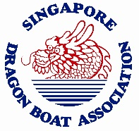

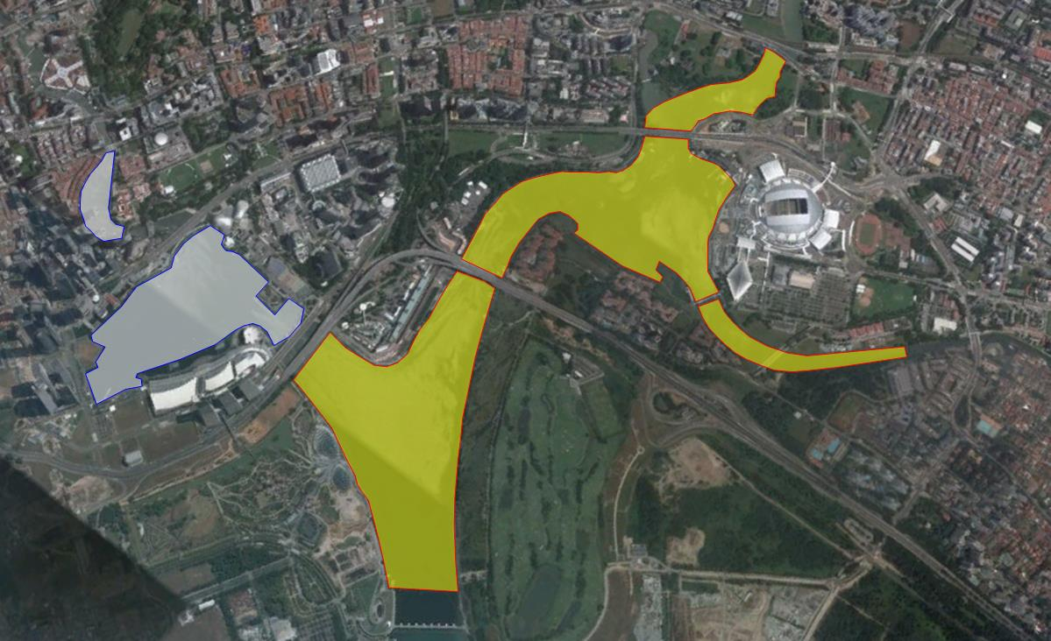

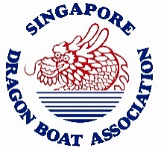





RAIZAL A JALIL

GENERAL MANAGER

SINGAPORE DRAGON BOAT ASSOCIATION

## 1 Emergency Contact List

|  |  |  |
| --- | --- | --- |
| **Designation in Team** | **Contact Person** | **Contact No** |
| Team Manager | Name | Hp |
| Deputy Team Manager | Name | Hp |
| Coach | Name | Hp |
| Captain | Name | Hp |
| Vice-Captain | Name | Hp |
| Emergency Services | Police | 999 |
| SCDF-Ambulance | 995 |
| PUB - Marina Barrage Operations Room | 6514 5951 |
| Weather/Lightning/Haze Information | NEA (Dial-a-weather)  NEA (Operator) | 6542 7788  6542 5059 |

*\* Please add any additional Contact Person(s) to the list at your own discretion*

## 2 Dragon Boat

2.1 22-crew Standard size dragon boat:-

a. 20 paddlers

b. 1 steerer at the stern

c. space for 1 person at the front (i.e. Drummer, Coach, Captain, etc.)

2.2 12-crew Small size dragon boat:-

a. 10 paddlers

b. 1 steerer at the stern

c. space for 1 person at the front (i.e. Drummer, Coach, Captain, etc.)

## 3 Crew

3.1 No restriction on gender mix.

3.2 According to International Dragon Boat Federation (IDBF) Competition Regulation and Rules of Racing (CR&RR):-

a. minimum age permitted to race is twelve (12) years old

b. the 12 year old must be accompanied by a parent and/or responsible adult appointed by the parent in the Crew and/or Dragon Boat participating in a race

3.3 For age younger than twelve (12) years old:-

a. not permitted to race

b. must be accompanied by a parent and/or responsible adult appointed by the parent in the Crew and/or Dragon Boat participating in the dragon boating activity at all times

3.4 There is no IDBF limit on maximum age.

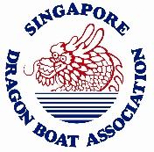

3.5 The Crew is responsible for own health status.

3.6 Team Managers/ Coach/ Captain will verify that Crew is fit before the start of the dragon boating activity.

## 4 Wearing of Personal Floatation Device (PFD)

4.1 Wearing of Personal Floatation Device (PFD) is compulsory.

4.2 The PFD shall comply with minimum ISO 12402-5.

4.3 For persons weighing 49kg and less, jock straps may be required, especially if they are children.

4.3 Equivalent standards such as EN, EU, USCG or equivalent are also accepted.

## 5 Wearing of Footwear

5.1 Wearing of footwear is compulsory.

5.2 Footwear must be non-slip kind, i.e. slippers, sandals, shoes, booties, etc.

## 6 Swimming Ability

6.1 No restriction on swimming ability.

6.2 Team Managers/ Coach/ Captain will verify Crew Member’s swimming ability before the start of the dragon boating activity.

6.3 Team Managers/ Coach/ Captain is responsible to brief the following to The Crew:-

a. Buddy System

b. Capsize Drill

## 7 Field of Play

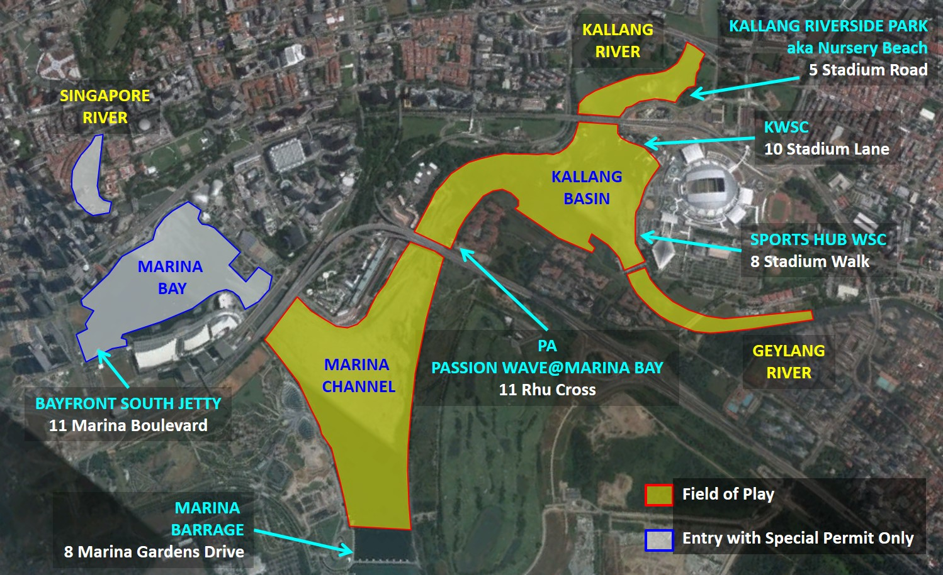



7.1 Emergency landing points are highlighted in blue:-

a. Kallang Riverside Park (AKA Nursery Beach)

Address: 5 Stadium Road

b. Kallang Water Sports Centre

Address: 10 Stadium Lane

c. Sports Hub Water Sports Centre

Address: 8 Stadium Walk

d. Passion Wave@Marina Bay

Address: 11 Rhu Cross

e. Marina Barrage

Address: 8 Marina Gardens Drive

f. Bayfront South Jetty

Address: 11 Marina Boulevard

7.3 Depending on the severity and nature of emergency, the dragon boat will be evacuated back to base (refers to the location where the dragon boat originated from) and/or to the nearest Emergency Landing Points, if critical.

7.2 Entry into Marina Bay and Singapore River is only with special permit from PUB.

## 8 Stay-In-Contact Policy

8.1 Team Managers/ Coach/ Captain are required to have their handphones with them during the dragon boat activity for emergency purposes, i.e. call Police 999, SCDF 995, etc.

## 9 Emergency Action Plan

9.1 Water Emergency refers to capsize, sudden onset of severe weather or other life threatening situation.

9.2 Dragon Boat activity shall be suspended and/or stopped until the emergency has been dealt with and the danger passed and/or mitigated enough to permit safe passage

9.3 The Crew shall head immediately back to base (i.e. from where they launched, etc.) or to the nearest emergency landing point

## 10 Inclement Weather Action Plan

10.1 Definition:

a. Heavy Rainfall

b. Thundery showers

c. Lightning strike



d. Haze

10.2 Team Manager/ Coach/ Captain shall rely on the National Environment Agency (NEA) website and/or MyNEA smart phone app for severe weather warning and/or indication.

10.3 Heavy Rainfall and/or Thundery Showers Action Plan

1. Upon the activation of Heavy Rainfall or Thundery Showers, the dragon boat activity shall be suspended and/or stopped until the all-clear is given via the NEA website and/or MyNEA app.
2. The dragon boats shall head immediately back to base (i.e. from where they launched, etc.) or to the nearest emergency landing point
3. For rain or showers not exceeding Heavy Rainfall or Thundery Showers conditions as indicated in the NEA website of MyNEA app, the dragon boat activity may continue provided all of the following conditions are possible:-

i. no lightning strikes

ii. visibility still clear up to minimum 800m

iii. water condition not detrimental to the safe handling of the dragon boat, i.e. not excessively choppy, etc.

iv. rainfall does not exceed collection of 10mm deep within 1 minute inside the dragon boat (which if not addressed, may lead to about ankle deep water within 10 minutes)

v. the crew has means to bail out the water from inside the dragon boat

vi. all safety provisions still in place and functional

vii. Team Manager/ Coach/ Captain required to immediately review the Risk Assessment and conclude that the risks are within acceptable tolerances

10.4 Lightning Strike Action Plan

1. Alternative to the NEA website and/or MyNEA App, the Team Manager/ Coach/ Captain can also depend on the Lightning Warning System (LWS) installed at the following location:-

i. Kallang Water Sports Centre

ii. Kallang Dragon Boat Nursery

iii. Sports Hub Water Sports Centre

iv. Passion Wave@Marina Bay

1. The LWS shall:

i. activate siren for about 30 second to 1 minute

ii. flashing warning light shall come on

iii. flashing warning light shall stay on the entire duration of active alert

iv. when flashing warning light goes off, it indicates the wet weather has passed

1. Upon activation of *EITHER* the NEA Website/MyNEA and/or LWS, the dragon boat activity shall be suspended and/or stopped until the all-clear is given via EITHER the NEA website/MyNEA app and/or LWS



10.5 Haze Action Plan

a. No dragon boating activity as long as NEA’s 24hrs and/or 1hr2.5 PSI reading equals/exceed 150 points.

## 11 Check Marina Barrage Gate Operation

11.1 Before the dragon activity, the Team Manager/ Coach/ Captain should check with PUB whether the Marina Barrage gates are in operation.

11.2 Team Managers/ Coach/ Captain can contact PUB’s Marina Barrage Operations Centre at Tel. 6514 5951, to check on status of the Marina Reservoir barrier gates.

11.3 If the gates are opened, the dragon boating activity shall be suspended and/or stopped until PUB closed them

11.4 The dragon boats shall head immediately back to base (i.e. from where they launched, etc.) or to the nearest emergency landing point



## ANNEX A: The Steerer

**1 Description**

1.1 According the IDBF Bye-Law 3.6.3, the Steerer is the crew member whose specific task is to steer a dragon boat with the aid of a steering oar or paddle.

1.2 The Steerer is also internationally known as ‘The Helm’ or ‘The Sweep’. In Singapore, the most common term used is ‘The Coxswain’ or just ‘The Cox’ in short.

1.3 Physical characteristic of a Steerer:

a. can either be male or female

b. minimum 18 years old

c. must be able to swim reasonably well (without pause) up to a minimum

distance of 50m, with and without the wearing of a personal floatation

device (PFD)

d. possess reasonable level of fitness

1.4 Must possess the following certification:

|  |  |  |
| --- | --- | --- |
| Level | Certificate | Remarks |
| 1 | Basic Helm Accreditation | Either full certification and/or valid probationary letter |
| 2 | Recreational Trainer |  |
| 3 | Technical Coach | Coach Level 1 and Higher |

**2 Responsibility**

2.1 Safety of the Crew. Know how many people are inside the dragon boat

2.2 The safety of the Dragon Boat, i.e. the condition of the dragon boat and its equipment

2.3 The safety of Other Users on the water

2.4 Ensure the Crew are wearing PFD and Footwear

2.5 Know who are the weak or non-swimmers in the crew. Know where these weak or non-swimmers are seated at all times.

2.6 Know how to navigate inside the reservoir:

i. designated field of play

ii. safe water traffic pattern, especially at the permanent race course site

iii. know where all the Restricted and No Entry Zones are



2.7 Responsible to maintain the dragon boat’s stability and to prevent collision and capsizing by controlling the dragon boat steerage as well as the crew’s movements inside the dragon boat.

**3 Boat Handling**

3.1 Assess the water and the weather conditions, being aware of any currents and wind, and pointing the boat into the wind when not moving.

3.2 Knowing approved safety procedures and what to do in the event of capsize or emergency.

3.3 Be aware of other vessels around his boat. Good practice periodically looking behind the dragon boat to be aware of any other approaching vessels.

3.4 Give the appropriate command to safely stop or navigate the dragon boat.

3.5 When encountering choppy water, wave and/or wake of a passing boat, Steerer should face the dragon boat into or away from the waves (bow-on or stern-on).

3.6 Employ the ‘Brace!” command to stabilize the dragon boat.

3.7 Collisions must be avoided at all costs, even stopping the boat if necessary.



## ANNEX B: Appointment of Boat Captain

## 1 Description

1.1 In accordance to the IDBF Water Safety Policy (WSP), Teams must appoint a Boat Captain to be in-charge of the crew while inside the dragon boat as well as during embarking and disembarking.

1.2 It should be understood that The Boat Captain may not have to necessarily be the Team Captain. The Boat Captain is more of a task specific role, activated only when the crew is inside the dragon boat.

1.3 The Boat Captain primary role is to control the crew’s actions inside the dragon boat, responsible for giving the command to move or stop the dragon boat.

**2 Steersperson as Boat Captain**

2.1 Traditionally, the role of Boat Captain would be assumed by the Steersperson.

2.2 Due to the steersperson’s elevated standing station inside the dragon boat, he/she will possess the best commanding views.

2.3 The Steersperson is the most preferred option (1st choice) as Boat Captain for all aspect of the sport of dragon boat – from recreational to competitive paddling.

**3 Drummer as Boat Captain**

3.1 The Drummer may also assume the role of Boat Captain. The elevated drummer’s seat station inside the dragon boat is sufficient enough to provide an excellent commanding view.

3.2 The Drummer is the least preferred option (2nd choice) as Boat Captain.

**4 Trainer or Coach as Boat Captain**

4.1 During recreational paddling or a training session where the Trainer or Coach is present with the dragon boat crew, The Trainer or Coach may also assume the role of the Boat Captain.

4.2 The Trainer or Coach vantage point at the fore part of the dragon facing the paddlers (similar to the drummer’s position in competitive paddling) is usually sufficient to allow the trainer or coach the best commanding views.

**5 Responsibility**



5.1 The Boat Captain is required to assume the responsibility to maintain the dragon boat’s stability and to prevent capsizing by controlling the crew’s movements, especially during the embarking/disembarking process.

5.2 The Boat Captain must know all the weak or non-swimmers in the crew. The Boat Captain must know where these weak / non-swimmers are seated at all times.

5.3 the Boat Captain is responsible to ensure that the entire crew is wearing their Personal Floatation Device (PFD) correctly and according to the manufacturer’s specifications.

5.4 In an emergency or dangerous situation that may lead to capsizing or swamping, the Boat Captain must initiate emergency measures to stabilize the dragon boat

5.5 If the danger persist, the Boat Captain is responsible to command the dragon boat to steer and move away from the dangerous area. The Boat Captain should consider returning to shore if need be.

5.6 If there is still no improvement to the dangerous situation (i.e. sudden onset of inclement weather, etc), the Boat Captain is required to command the dragon boat to return to the nearest shore immediately to seek shelter and wait out the danger or to seek help.

**6 Emergency Situations**

6.1 In the event of capsize or swamping, the Boat Captain must maintain control of the Crew inside the water at all times.

6.2 Boat Captains must initiate the **Capsize/Swamping Drill** and make sure that all crew members are accounted for and initiate a quick search for any missing crew members.

6.3 When every crew member is accounted for and the condition is safe, the Boat Captain may initiate the **Capsize or Swamping Recovery Drill**.

6.4 If Rescuers (in the form of other dragon boats, hereafter known as Rescue Dragon Boat) are present, the Boat Captain may request the Rescue Dragon Boat to recover the non-swimmers and weak-swimmer of his/her crew in the water, provided there is space available inside the Rescue Dragon Boat.

6.5 When it is safe, the Boat Captain may request for the Rescue Dragon Boat to tow the capsize or swamped dragon boat to the nearest shore or landing point.

6.6 If there is a missing crew member(s), the Boat Captain must inform the Emergency Services (SCDF, Police, etc.) at the earliest and safest possibility.



## ANNEX C: Buddy System

**1 Description**

1.1 In accordance to the IDBF Water Safety Policy (WSP), Teams are required to adopt the Buddy System.

1.2 In the Buddy System, each person inside the dragon boat is also responsible for the person they are paired with.

1.3 The system accorded each crew with a partner for mutual checking on safety and support in an emergency such as during a capsize or swamping.

**2 Requirements**

2.1 Pair the paddlers according to their seating positions.

2.2 The person at the front (i.e. Trainer. Coach or Drummer) will be paired with the 1st Row.

2.3 The steersperson will be paired with the Last Row.

2.4 The pairing sequence should be according to the diagram shown:-



2.5 Typical DB12 Crew Buddy System pairing





2.6 Typical DB22 Crew Buddy System pairing



**3 Emergency Inside the Dragon Boat**

3.1 Buddies will look out for each other’s well-being, sign of distress or any other visible negative physical contra-indications.

3.2 Should any dangerous or emergency situation arises, the Buddy for the person in distress **MUST** alert the Boat Captain.

3.3 If your Buddy is injured or unwell, you are expected to offer any help and assistance that you possibly could to help your Buddy cope until he/she could be evacuated from the dragon boat.

**4 Capsize & Swamping Emergency**

4.1 In a capsize or swamping emergency, after checking on your own physical condition and that there are no injuries, check on the physical condition of your Buddy.

4.2 If your Buddy is injured or unwell, you **SHOULD ONLY OFFER** any help or assistance if it is within your control and ability to do so. *You must not endanger yourself in the process.*

4.3 Alert the Boat Captain or the first Rescuer on the scene that your Buddy is injured or unwell and require urgent attention.

4.4 If your Buddy is physically missing or missed the roll call, **IMMEDIATELY** alert the Boat Captain or the first Rescuer on the scene.



## ANNEX D: Capsize Drill

**1 Description**

1.1 *Capsize.* The dragon boat is deemed to have rolled-over (complete hull-up overturn) or tip-over (lying on its side in the water).

1.2 *Swamping*. The dragon boat is either fully or partially filled with water, submerged in the water but still in the upright position

**2 Capsize Drill**

2.1 The Crew-member must conduct a quick self-check on him/herself.

*Look out for pain or bleeding injuries as these could escalate into life-threatening medical emergency.*

2.2 Buddies **MUST** then do a quick peripheral search of the area to spot one another

2.3 Regardless of injury or no, Buddies must inform each other of their condition and well-being.

*This will ensure that Buddies are aware of each other’s status after capsize or swamping.*

2.4 Crew is required to stay close to the capsized/swamped dragon boat and try to maintain any handhold onto the hull of the boat.

*The dragon boat is designed with reserved buoyancy and will not sink immediately. Staying close to the boat will facilitate faster and easier accounting of personnel as well as rescue.*

2.5 Keep calm and composed

*Panic and anxiety may interfere with the Boat Captain’s or Rescuers’ attempts to control the situation.*

2.6 Boat Captain to initiate a roll call to account for Crew.

*The roll call can be done by calling out the names or pre-assigned numbers, etc.*

2.7 During the roll-call, inform the Boat Captain if you have any injuries.

*If your Buddy is too injured to account for him/herself, then you must inform the Boat Captain of his/her injured condition.*

2.8 Buddies **MUST** interrupt the processes mentioned above, if they cannot physically or visually account for their assigned Buddy.

*Inform the Boat Captain immediately that your buddy is missing.*

2.9 If a Crew-member is missing, everyone **MUST** assume that he/she is unconscious.



*Do a quick visual search within your peripheral vision and try to locate the missing crew.*

2.10 If the missing Crew is not within your peripheral vision, assume he/she is under the overturned hull of the dragon boat. Boat Captain to initiate a leg sweep procedure to feel for anyone trapped underneath the boat.

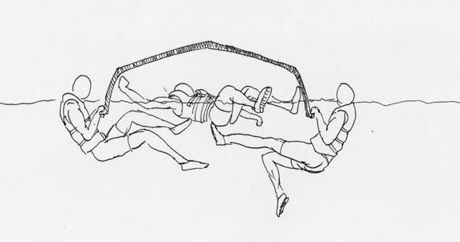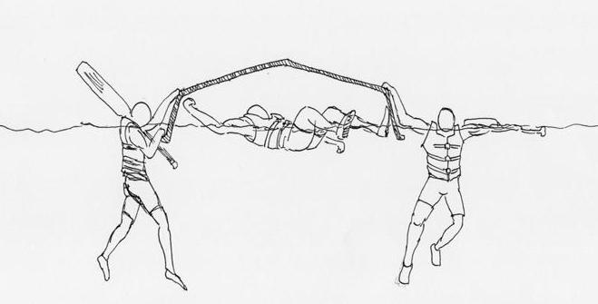

**3 Availability of Rescue/Safety Boats**

3.1 Applicable in a race where Rescue Boats are available OR whenever a dedicated Safety Boat is assigned.

3.2 Once Rescuers arrived, Boat Captain to immediately inform the Rescuer on any missing Crew.

3.3 If the Boat Captain is unable to account for The Crew with a roll-call, he/she must immediately make this known to the Rescuer. The Rescuer will then immediately take-over the accounting for the whereabouts and status of the crew.

3.4 The Boat Captain should also inform the Rescuer who the weak or non-swimmers are so that the Rescuer may prioritize them for first recovery.

3.5 The Crew in the water must execute the Rescuer’s instructions.

3.6 The Crew in the water must also be wary of the Rescue or Safety Boat’s propellers.

**4 Availability of Other Dragon Boats in the Vicinity**

4.1 Applicable if there are other dragon boats within the vicinity of capsize or swamping.

4.2 Teams in other dragon boats are encouraged to come to the aid of a capsized or swamped dragon boat provided it is within their ability to do so and there is no apparent danger to them by doing so.

4.3 The other dragon boat may offer holding support or initiate recovery of crew in the water if there is space available and safe to do so.



4.4 The other dragon boat may serve as the following:-

a. staging platform to conduct rescue operations

b. tow the capsized or swamped dragon boat to the nearest shore

c. shuttling the capsized crew between the capsize location and shore

**5 Self Recovery**

5.1 Applicable if the capsized or swamped dragon boat crew is alone and unsupported

5.2 If possible, especially in a swamping, initiate stability recovery by bailing out the water.

5.3 Abandon the capsized or swamped dragon boat and initiate a group swim to the nearest shore.

5.4 Boat Captain must keep the entire crew together – do not allow any individual to wander off on their own or drift away.

**6 Swamping Recovery**

6.1 Max. two(2) persons getting back on board

6.2 Bail out water to restore stability

6.3 All the while, remaining crew to stay with swamped dragon boat, with secure handhold

6.4 Once stability restored, taken as when entire dragon boat freeboard is above the water line, crew may board the dragon boat

**7 Capsized Recovery**

7.1 Attempt to roll the dragon boat back to right side up (in a completely overturned capsized situation, this may be more difficult and challenging and should only be attempted with great caution)

7.2 Max. two(2) persons getting back on board

7.3 Bail out water to restore stability

7.4 All the while, remaining crew to stay with capsized dragon boat, with secure handhold

7.5 Once stability restored, taken as when entire dragon boat freeboard is above the water line, crew may board the dragon boat

**8 Boat-Swim to Shore**

8.1 If possible, carefully turn the boat right side up. Otherwise, leave it in its’ capsized/ swamped state



8.2 Entire crew in the water to maintain hand-hold at all times with the boat, even if still in its capsized/swamped state.

8.3 Entire crew began swimming towards the nearest shore, pushing/tugging the capsized/swamped boat along.

8.4 Do not swim ahead or behind the boat as the momentum or lack of, may cause you to bump into them, causing injuries

**9 Back on Shore**

9.1 Once back on shore, the Boat Captain must ensure that all crew are accounted for.

9.2 In a race event, the Boat Captain must inform the Chief Boat Marshall (CBM) on the status and well being of his/her crew. Immediately inform the CBM of any injured or missing crew member.

9.3 In a recreational or training session, if the capsized/swamped crew is able to recover back to the reservoir’s operations centre (either SDBA or PA Water Venture centres), the Boat Captain must inform the operator of any injured or missing crew member.

9.4 In self-recovery to the nearest shore, the Boat Captain must immediately sought the general public’s help to raise the alarm (by calling the emergency services) concerning any injured or missing crew member. The Boat Captain must also attempt to quickly inform the reservoir operations centre operator.



## ANNEX E: Emergency Response Plan

EMERGENCY OCCURS!

boat captain assessed the nature of the emergency

EXECUTIVE DECISION

BOAT CAPTAIN DECIDES TO SUSPEND OR STOP THE ACTIVITY.

RETURN TO BASE OR NEAREST EMERGENCY LANDING point

MASS LIFE THREATHENING EMERGENCY

1. evacuate **entire crew** from the boat

2. call emergency services

3. INFORM SDBA

CREW MEMBER(S) SUFFERED A LIFE THREATHENING OR NON-LIFE THREATHENING EMERGENCY

1. Evacuate **the caSUALTy** from the boat

2. call the emergency services

3. INFORM SDBA

**POST EVENT**

1. Team Manager inform SDBA

2. SDBA shall Inform relevant authorities, PUB, etc.

**NON LIFE THREATHENING INJURIES**

1. Team Manager conduct investigation & compile report

2. Reviews both Event Safety Plan and

Risk Assessment

3. Share findings with Crew

**LIFE THREATHENING INJURIES**

1.Team Manager conduct investigation & compile report

2. Casualty evacuated to hospital, if necessary

3. Reviews both Event Safety Plan and

Risk Assessment

4. Share findings with Crew

5. Inform SDBA

**FATALITY**

1. Boat Captain orders activity to be stopped

2. Call the Police

3. Conduct investigation &

compile report

4. Reviews both Event Safety Plan and

Risk Assessment

5. Inform SDBA

6. SDBA shall informed relevant authorities, PUB, etc.

**POST EVENT**

1. Inform SDBA

2. SDBA shall iInform relevant authorities, PUB, etc.

3. SDBA reviews Safety Plans and Risk Assessments

4. SDBA share findings with relevant authorities, PUB, etc.

5. SDBA shares case with dragon boat community

**POST EVENT**

1. SDBA investigates and compile report

2. SDBA reviews Safety Plans and Risk Assessments

3. SDBA share findings with elevant authorities, PUB, etc.

4. SDBA shares case with dragon boat community



< END >