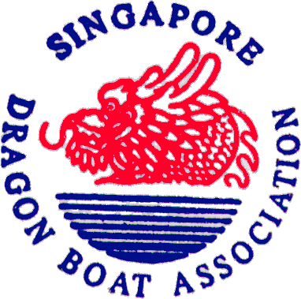
SINGAPORE DRAGON BOAT ASSOCIATION

Name of Programme: SDBA Foundation Instructor Course 2023

Date/Time: 7th, 9th, 14th and 16th November 2023

7.00 pm to 9.30 pm (Theory)

19th November 2023

8.00 am to 6.00 pm (Practical Assessment)

Fee: S$540.00 (inclusive of 8% GST) – FULL PRICE
S$432.00 (inclusive of 8% GST) – EARLY BIRD FEE FOR THE MONTH OF NOVEMBER

Venue: NSA Meeting Room (2 & 3)
Sport Singapore
3 Stadium Drive
Singapore 397630

Closing Deadline: Sunday, 5th November 2023, 12:00 pm.

Pre-requisite:
- Participants must be at least 18 years of age at the time of enrollment.
- Able to swim 50 meters without PFD.
- Completion of Dragon Boat Basic Helm Certification or equivalent experience
- Participants must hold a valid Standard First Aid with CPR and AED certification accredited by SRFAC
- Show proof of a minimum of 100 hours of steering as the helm in the dragon boat.
- Participants are required to have a specific level of physical fitness to proficiently operate the Dragon Boat, manage emergencies, and effectively communicate with the crew.

REGISTRATION FORM (Please type in your entries)
Name (as in NRIC/Passport)
(In bold/clear capital letters)
(Names not clearly written will not be accepted)
Mailing Address

Mobile No
(do not provide Home & Office No)
Email

Name of Dragon Boat Team

Name of Dragon Boat Team Manager/Coach

Endorsement of Team Manager/Coach
Name of Trainer
(who trained you to helm) *
No of Years as Paddler

Last 5 Competitions as Paddler
& Year

Indemnity Form

- By registering in this SDBA Foundation Instructor Course 2023, I have agreed that I will not hold the Singapore Dragon Boat Association (SDBA), their appointed staff or officials, responsible for any mishaps, injuries, damages or loss of life and/or property that may occur in the course, or as a result of participating in this SDBA Foundation Instructor Course 2023. I will indemnify the SDBA, their appointed staff or officials, against any actions, proceedings, liabilities, claims, damages and expenses by any party however arising out of or in connection with this course.

I. Declaration and Authorisation (For 21 years old and above)

I hereby apply for the admission to the SDBA Foundation Instructor Course 2023. I declare that the information given in this is true and complete. I understand if falsified information is submitted, admission will be rescinded. If accepted for this SDBA Foundation Instructor Course 2023, I will comply with all stated in the above (Point 1) of the SDBA.

________________________________ __________________
Signature of Participant Date

II. Parent’s/Guardian’s Consent (For below 21 years old)

I, (Name) _______________________________, NRIC No.: _________________ *parent/guardian of (Name of participant) ____________________________ *consent / do not consent to my *child / ward participating in the abovementioned course.

I understand that although SDBA will take all the necessary precautions to ensure the safety of my *child / ward, SDBA and their appointed staff or officials will not be liable for any accident, injury or loss sustained by my *child / ward during the course except where the same is caused by either the negligence or wilful act of omission of SDBA or their appointed staff or officials.

I hereby apply on behalf of my *child / ward for the admission to the SDBA Foundation Instructor Course 2023, I declare that the information given in this is true and complete. I understand if falsified information is submitted, admission will be rescinded. If accepted for this SDBA Foundation Instructor Course 2023, my *child / ward will comply with all stated in the above (Point 1) of the SDBA.

______________________________ ___________________
Signature Date
Please note the following:

- You may submit the completed application form via soft copy to admin@sdba.org.sg. Payment must be made by Bank Transfer to:

By Bank Transfer: -
Name of Bank: DBS Bank Ltd
Name of Account: Singapore Dragon Boat Association
Account No: DBS Current 025-902774-9
Bank Code: 7171
Branch Code: 025

By PAYNOW via UEN
UEN No: S87SS0101F

- For further information, please Email: admin@sdba.org.sg

___________________________________________________________________

